AI LAB TASK 2
PEAS Specifications of Two Intelligent Agents

Student Name: Muhammad faseeh ijaz
Roll Number: su92-bssem-s25-044
Course: Artificial Intelligence Lab

Introduction

PEAS is a simple way to describe how an intelligent agent works. It includes four parts: Performance Measure, Environment, Actuators, and Sensors. In this assignment, I used PEAS to explain two examples: a delivery robot and an AI student-support agent.

- PEAS Specification: Delivery Robot

A delivery robot carries parcels from one place to another, for example, inside a university, hospital. It needs to find the correct route and deliver each parcel safely.

Performance Measure

The robot should deliver the right parcel to the right place and try to arrive on time. It should avoid hitting people or objects, protect the parcel from damage.

Environment

The robot works in places such as rooms, doors, and elevators. It may meet students, staff, and other objects. It also needs to know where parcels are collected, where they must be delivered.

Actuators
The robot uses wheel motors to move and turn, and brakes or motor controls to stop. It may have a locked compartment or a small robotic arm to handle a parcel. A screen, light, or speaker can tell the receiver when the delivery has arrived.

Sensors
Cameras can help the robot see people and objects. Distance sensors, such as LiDAR or sensors, help it measure how close objects are. Wheel encoders help it estimate its location, while a battery sensor shows how much charge is left.

Operational assumptions

For this example, I assume the robot works indoors in a building or campus that has already been mapped. It has a delivery destination and permission to use certain corridors and elevators. It does not travel on public roads. Its sensors may sometimes make mistakes, and people can suddenly block its path. If it cannot move safely, it should stop or ask a person for help.

Constraint or performance trade-off

The main trade-off is speed versus safety. Moving quickly can save time, but it may be harder for the robot to stop if someone suddenly crosses its path. For this reason, safety should come before speed, especially in crowded areas.

- PEAS Specification: LLM-Based Student-Support Agent

An LLM-based student-support agent is an AI assistant that can answer students’ questions, explain course topics, help with revision plans, and point students towards useful learning materials.

Performance Measure

The agent should give correct and useful answers and explain topics in clear language. It should reply in a reasonable time and admit when it does not know something instead of making up an answer. It must also respect student privacy and support honest academic work.

Environment
The agent interacts with students through a chat window or learning portal. Its information may include course outlines, lecture notes, assignment instructions, and official university guidance. It may also work with an online learning system if it has permission. Students can have different learning needs, language levels, and deadlines.

Actuators

The agent responds by writing answers, explanations, examples, and summaries. It can prepare a revision plan or checklist. If an approved search tool is available, it can look for relevant course documents. It can also share official links or suggest contacting a teacher or student adviser.

Sensors
The agent uses the student’s messages and follow-up questions as its main input. It can also read files or images uploaded by the student. If connected to an approved search tool, it can use the results it receives. It may also receive limited course information from an authorized university system.

Operational assumptions and tool access

In this assignment, the agent can read messages and files that a student chooses to share. It can search approved course documents and public university information through an authorized document-search or web-search tool. Access to a learning-management system is possible only if the university has enabled a connection and granted permission. The agent cannot normally see private grades, attendance, student records, or email. It cannot submit assignments, change grades, or contact staff unless an approved tool allows that action and the required permission is given. Since online information can be incomplete or out of date, important details should be checked with official university sources.

Constraint or performance trade-off

The main trade-off is speed versus accuracy and privacy. Giving an instant answer is convenient, but checking reliable course material can take longer. The agent should give a checked answer when possible and say when it is unsure instead of guessing. It should only use the student information needed to help.

Conclusion

PEAS helps explain what an intelligent agent needs to do, where it works, what actions it can take, and what information it can receive. The delivery robot works mainly in a physical place, while the student support agent works with messages and digital learning resources. Both need to be useful and reliable, but the robot must give priority to physical safety and the student-support agent must pay close attention to accuracy, privacy, and the limits of its tools.

Code compilation :

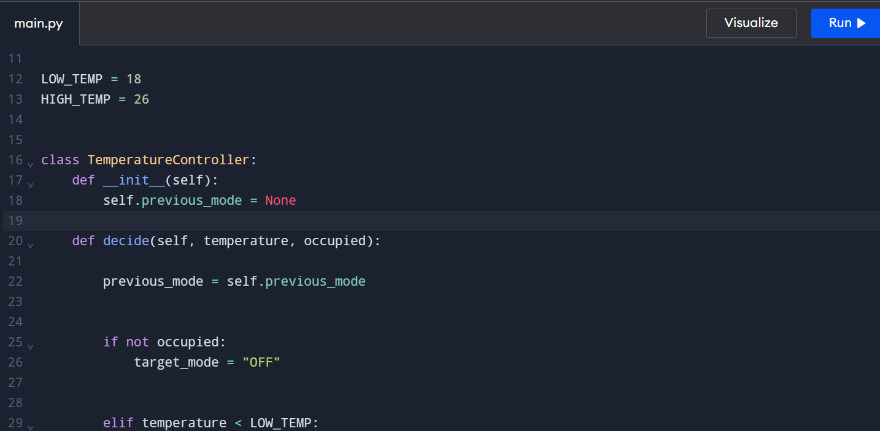

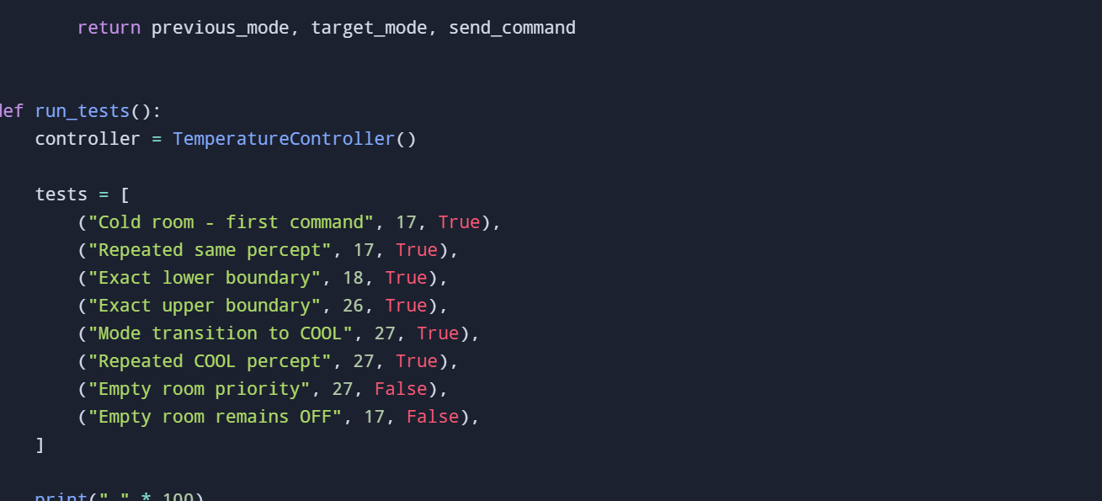

Output:

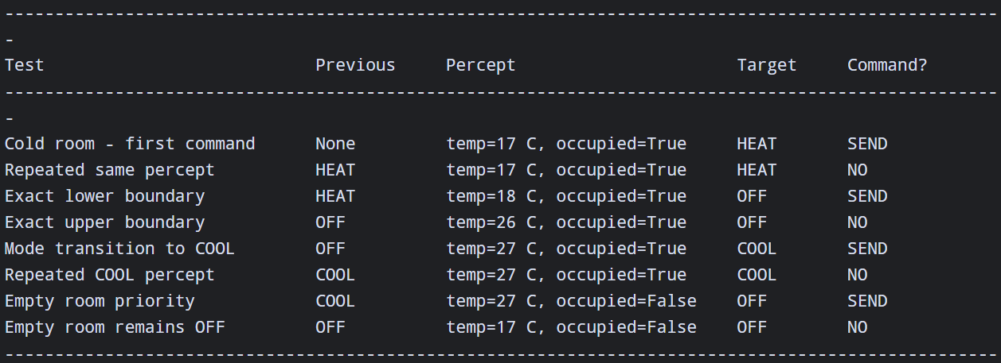

Full code :

"""
Example thresholds:
Below 18 C: HEAT
Above 26 C: COOL
From 18 C to 26 C: OFF

Occupancy priority:
If the room is empty, the target mode is always OFF.
Send a command only when the target differs from the previous mode.
"""

LOW_TEMP = 18
HIGH_TEMP = 26

class TemperatureController:
def __init__(self):
self.previous_mode = None

def decide(self, temperature, occupied):
# Remember the previous mode before processing this percept
previous_mode = self.previous_mode

# Occupancy priority
if not occupied:
target_mode = "OFF"

# Temperature rules
elif temperature < LOW_TEMP:
target_mode = "HEAT"

elif temperature > HIGH_TEMP:
target_mode = "COOL"

else:
target_mode = "OFF"

# Check whether a new command is required
send_command = target_mode != previous_mode

# Store the target mode for the next decision
self.previous_mode = target_mode

return previous_mode, target_mode, send_command

def run_tests():
controller = TemperatureController()

tests = [
("Cold room - first command", 17, True),
("Repeated same percept", 17, True),
("Exact lower boundary", 18, True),
("Exact upper boundary", 26, True),
("Mode transition to COOL", 27, True),
("Repeated COOL percept", 27, True),
("Empty room priority", 27, False),
("Empty room remains OFF", 17, False),
]

print("-" * 100)
print(
f"{'Test':30} {'Previous':12} "
f"{'Percept':28} {'Target':10} {'Command?':10}"
)
print("-" * 100)

for name, temperature, occupied in tests:
previous, target, send_command = controller.decide(
temperature, occupied
)

previous_text = (
previous if previous is not None else "None"
)

percept = f"temp={temperature} C, occupied={occupied}"
command_text = "SEND" if send_command else "NO"

print(
f"{name:30} {previous_text:12} "
f"{percept:28} {target:10} {command_text:10}"
)

print("-" * 100)

if __name__ == "__main__":
run_tests()

